Lab 1
Securing Wireless Networks
Objective:
The purpose of this lab is for the student to understand, create and implement a wireless network. Students will also utilize IOS commands to explore and configure a wireless network using an AP and implementing encryption.
Diagram:
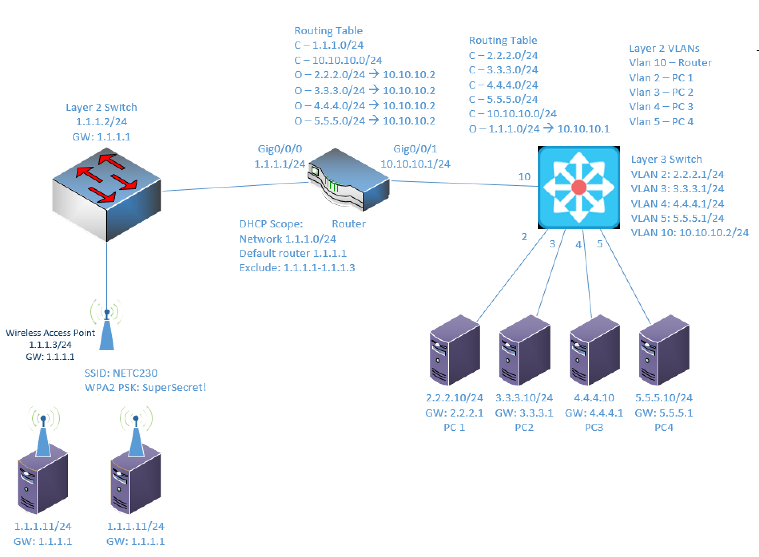
Components:
6 – PC’s, 4 with an Ethernet NIC, 2 with wireless NIC’s
1 – Cisco 3650 Layer 3 Switch
1 – Cisco 2960 Layer 2 Switch
1 – AP-PT-N Wireless Access Point
1 – Cisco 4321 - 2 Port Router

Procedure:
- Connect all PC’s together on the layer 3 switch and put their static IP addresses, subnet masks and gateways on them. Test connectivity by pinging each machine within the network.
- Label the Layer 3 switches VLAN IP addresses and ports below
Layer 3 Switch
VLAN | IP | Switch Port
2 | 2.2.2.1 | Gig1/0/2
3 | 3.3.3.1 | Gig1/0/3
4 | 4.4.4.1 | Gig1/0/4
5 | 5.5.5.1 | Gig1/0/5
10 | 10.10.10.2 | Gig1/0/10

- Label the routing tables for the Layer 3 switch and router below.
Router | Layer 3 Switch
C – 1.1.1.0/24 | C – 2.2.2.0/24
C – 10.10.10.0/24 | C – 3.3.3.0/24
O – 2.2.2.0/24 -> 10.10.10.2 | C – 4.4.4.0/24
O – 3.3.3.0/24 -> 10.10.10.2 | C – 5.5.5.0/24
O – 4.4.4.0/24 -> 10.10.10.2 | C – 10.10.10.0/24
O – 5.5.5.0/24 -> 10.10.10.2 | O – 1.1.1.0/24 -> 10.10.10.1

- Place the switch ports into the proper vlans. Configure all of the switches vlan IP addresses.

- Enable routing on the Layer 3 switch
- View the routing table on the Layer 3 switch
- Verify that the PC’s on the switch can ping each other
- Configure the IP addresses on the router interfaces and turn the interfaces on
- Configure OSPF on the Layer 3 switch and the router.
- On the router create a DHCP pool called net1. Use the 1.1.1.0/24 network and a gateway of 1.1.1.1. Remember to Exclude the router’s IP address.
  - What commands did you enter?
ip dhcp excluded-address 1.1.1.1
!
ip dhcp pool net1
network 1.1.1.0 255.255.255.0
default-router 1.1.1.1
- Click on the Access Point and Port 1 to configure wireless settings.
- Enter the name of the SSID shown in the diagram (NETC230)
- Choose WPA2-PSK for the Authentication
- Enter the PSK shown in the diagram (SuperSecret!)
- Make sure the Encryption is set to AES. TKIP is no longer considered secure. Screen shot your Wireless AP setup and paste below.
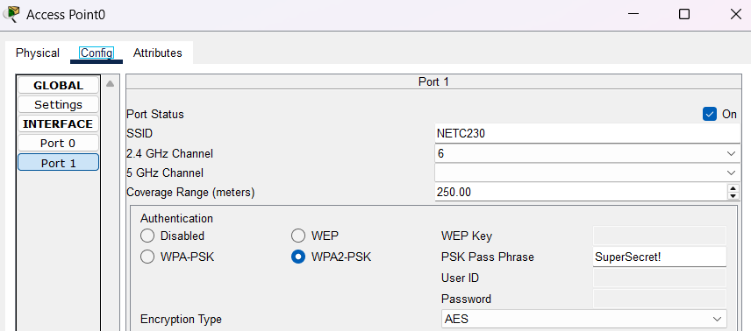

- Click on the PC and then the Wireless0 tab on the left.
- Configure the same settings we used for the wireless access point.
  - SSID: NETC230
  - Auth: WPA2-PSK
  - PSK: SuperSecret!
  - Encryption: AES
- The PC should automatically join the WAP at this point. If it doesn’t after a minute or so, disable the wireless card using the checkbox at the top and then re-enable. Double-check your settings. Sometimes the encryption goes back to TKIP.
- Screen shot one of your PC’s Wireless configuration and paste below.
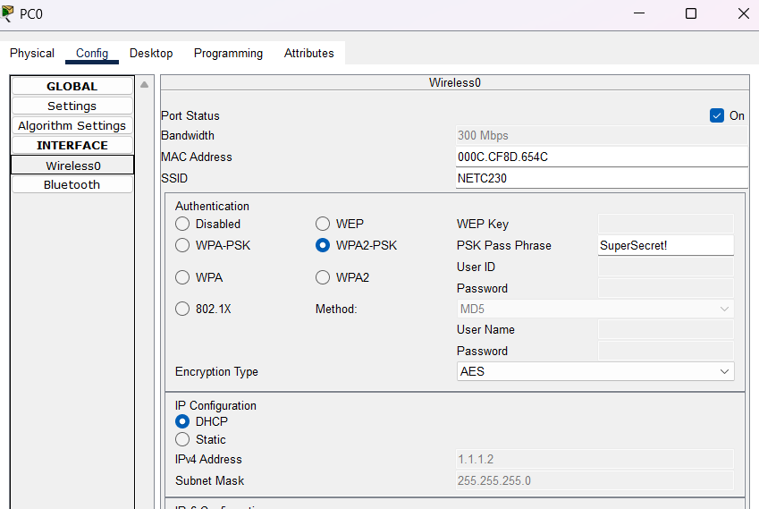
- Next, verify the wireless PC’s have IP addresses and can ping everyone.

- Create the lab diagram below (PCs, router and switch connections) in Packet Tracer or Visio. Label the IP addresses, subnet masks, and gateways used by each device. Label the routing tables next to the switch and router and the switches vlan IP addresses and port vlan information. Label the wireless SSID and keys next to the AP and wireless clients. Label the router DHCP scope.

